November 2000 Issue No 6
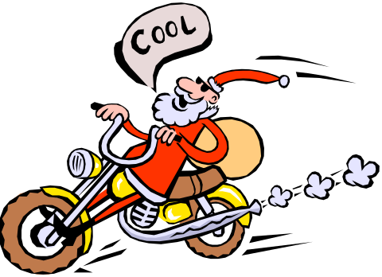

THE Balt e-Mail
NEW LOOK MILLENNIUM EDITION

It's that time of year again and arrangements are well in hand for the ‘squash and curry club’s Christmas curry night out.

This year’s MILLENNIUM event is to be held at the BOLAKA SPICE at Leek, on Wed 13th December.
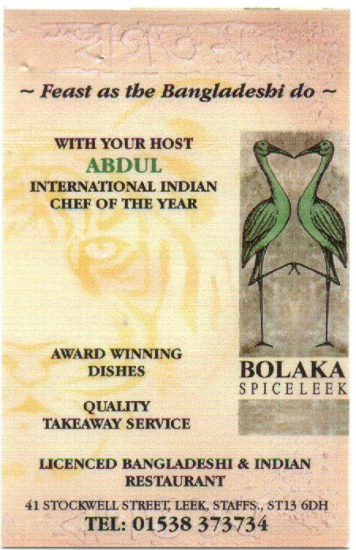
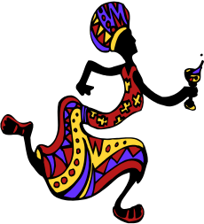The festivities will kick off at The Glebe at or before 5.00pm. Transport to and from Leek will be by bus and should cost no more than £10, depending on the numbers. The bus will leave the Glebe at around 5.30pm returning from Leek at around 11.30pm. A short break en-route will be taken at a mystery pub.

Any suggestions for next year’s Xmas curry, or any of next year’s monthly Squash & Curry nights out will be gladly received. This year’s suggestion was made by Dave Thacker. Next year it could be yours. Outstanding proposals include Naseebs (lads night out), Llandudno (still high on the reserve list), Birmingham (Sparkbrook), Bradford and Congleton.

So, to book your place and avoid disappointment contact Yup on ext. 2164. A deposit of £10 for transport will be required when booking. (Any difference will be refunded.) Don’t miss out!

PS Did you know there are currently around 8000 Indian restaurants in the UK making one such eatery for every 6000, or so, of our total population. Given the demographic and geographic realities of this fact, there is almost sure to be an Indian Restaurant in every British small town or large village of 2000 or more inhabitants. Whoopee!

